**Assignment – Individual Project**

**(50% of Total Module Marks) Submission Deadline: 17 Nov 2024 (23:59)**

This Assignment contains TWO Sections.

Section A is worth 40 marks and Section B is worth 60 marks.

Answer ALL questions in Section A. Each question is worth 20 marks.

Select **one** of the following topics for Section B.

You are required to complete an individual project that involves implementing an AI/ML solution using Python and relevant dataset(s).

Section A

# A1. Route Finding (20%)

* + 1. Choose one **uninformed** search algorithm and one **informed** search algorithm.
    2. Design and implement **both** algorithms in Python to find an optimal path from TSW (Tuen Mun) to TY (Tsuen Wan). The numbers on the edges of *Figure 1* represent distances in kilometers.
    3. Compare the results of the two algorithms and analyze factors like time complexity and path optimality.

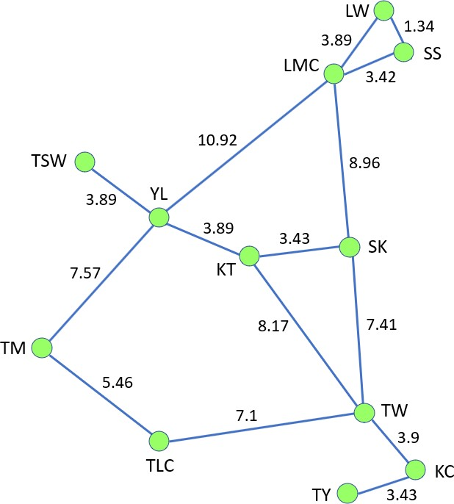 *Figure 1*

# A2. Map Coloring(20%)

* + 1. Design and implement the Map Coloring Problem as a CSP on the map of ***Figure 2***.
    2. Assign colors to areas *A* to *N* only (You may neglect the original colors).
    3. Use Python and the package *python-constraint*.
    4. Use as few colors as possible.

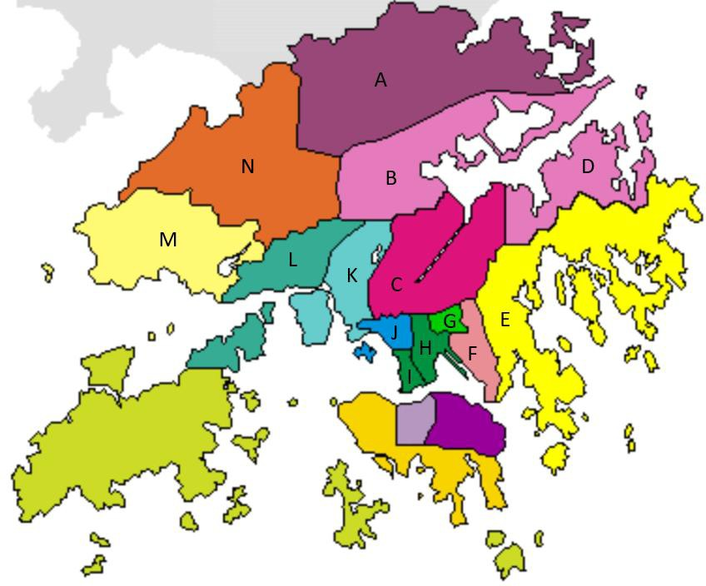

*Figure 2*

Section B

You are required to complete that involves implementing an AI/ML solution using Python and relevant dataset(s). Your tasks are outlined under Mark Distribution. The deliverables for this assignment include:

* Dataset(s)
* Python Code
* Project Report (min. 300 words)

### **Topics**

Select **one** of the following topics for your project:

1. **E-commerce Sentiment Analysis**
   * Analyze customer reviews to determine sentiment towards products or services.
2. **Traffic Signs Detection and Recognition**
   * Develop a system to detect and classify traffic signs from images or videos.
3. **News Classification and Summarization**
   * Classify news articles into categories and generate concise summaries.
4. **Sales Prediction**
   * Predict future sales trends based on historical data using regression models.
5. **Fraud Detection in Financial Transactions**
   * Identify fraudulent activities using machine learning classification techniques.
6. **Chatbot Development with Natural Language Processing**
   * Create an AI-powered chatbot capable of handling customer inquiries.
7. **Recommendation Systems**
   * Build a system that provides personalized recommendations (e.g., movies, products).
8. **Environmental Data Analysis**
   * Analyze environmental data to predict air quality or weather patterns.
9. **Any Other ML/DL Applications**
   * Propose your own project topic related to AI/ML for approval.

# Mark Distribution

# Problem Analysis - 10%

# Clearly define the problem and its significance.

# Outline objectives and expected outcomes.

# Data Preparation & Analysis - 10%

# Collect and preprocess the dataset(s).

# Perform exploratory data analysis.

# Solution Design - 10%

# Design the architecture and select appropriate algorithms/models.

# Justify your choices.

# Solution Implementation - 10%

# Develop and execute the Python code effectively.

# Ensure code is well-documented and efficient.

# Oral Presentation - 20%

# Duration: 10-15 minutes.

# Slides: Maximum 15 slides.

### ***Oral Presentation Guidelines***

* **Preparation**:
  + Develop a structured script to ensure all key points are covered within the time limit.
  + Create visual aids (e.g., PowerPoint slides) to support your presentation.
* **Content**:
  + **Introduction**: Briefly introduce your project topic, objectives, and its relevance.
  + **Methodology**: Explain the methods and tools used, including data sources and algorithms.
  + **Results**: Highlight the main findings with appropriate visuals.
  + **Conclusion**: Summarize the key outcomes and their implications.
  + **Reflection**: Discuss what you learned, any obstacles you overcame, and potential future work.
* Slide Requirements:
  + Maximum: 15 slides.
  + Content: Concise text, relevant visuals, and clear headings.
  + Design: Professional and consistent formatting. Avoid excessive text and ensure readability.

**\*\*\* THE END \*\*\***

* + - 1. Kaggle: [https://www.kaggle.com/datasets](http://www.kaggle.com/datasets)
      2. Data.Gov.hk: https://data.gov.hk/en/

**Referencing and Citation:**

* Properly reference and cite any articles, datasets, or resources used in your report and presentation.
* Consult your language teacher if you need guidance on citation formats.
* Failure to do so may result in a loss of marks.